Cache Invalidation
Scaling & Architecture, Day 4/25: Cache Invalidation 🧵
There's this famous joke in computer science.
"There are only two hard problems: cache invalidation and naming things."
After 12 years of building backend systems, I can confirm. Cache invalidation is both of them.
Here's the core problem:
Your database has the truth. Your cache has a copy. The moment someone writes new data to the database, the cache is lying. It's serving the old version. And it will keep lying until someone tells it to stop.
That "telling it to stop" part? That's invalidation. And there are multiple ways to do it. Each with different tradeoffs.
The question is never "should we cache?" It's:
1. When do we update the cache?
2. How stale is too stale?
3. What happens if the cache and database disagree?
Three write strategies handle question 1. Two invalidation approaches handle question 2. And question 3 is where production incidents live.
Let me walk through all of them.
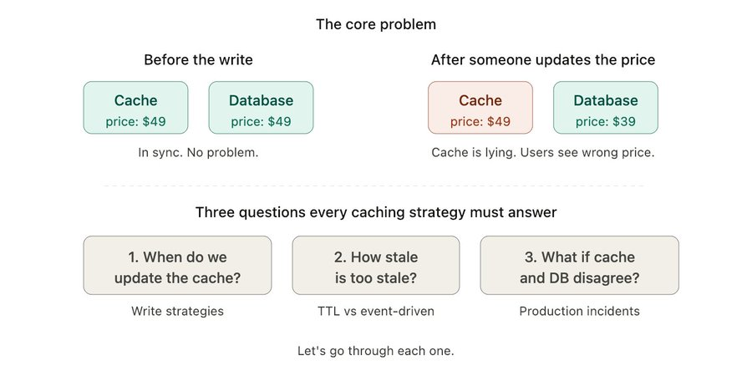
Strategy 1: Write-through
The simplest approach. When you write data, you write to both the cache and the database at the same time.
How it works:
1. User updates their profile
2. App writes the new data to the database
3. App also writes the new data to the cache
4. Both are now in sync. Done.
Why it's good:
Cache and database are always consistent. No staleness window. No lag. The moment data is written, the cache has the latest version.
This is great for data where even a few seconds of staleness is unacceptable. Think account balances, inventory counts, anything where "showing the old value" means real problems.
Why it's tricky:
Every write is now TWO writes. Database + cache. This means:

- Slower writes. You're waiting for both to complete. If your cache is in a different region, that's added latency on every write.
- What if one fails? Database write succeeds but cache write fails. Now they're out of sync anyway. You need error handling for this.
- Wasted cache space. You're caching data the moment it's written. But what if nobody reads it for the next 3 hours? You just used cache memory for nothing.

When to use it:
- Read-heavy data that MUST be fresh (product prices, user permissions, feature flags)
- Data that gets read almost immediately after being written
- Systems where consistency matters more than write speed

When to skip it:
- Write-heavy workloads (you'll bottleneck on double-writes)
- Data that's written often but read rarely (analytics events, logs)
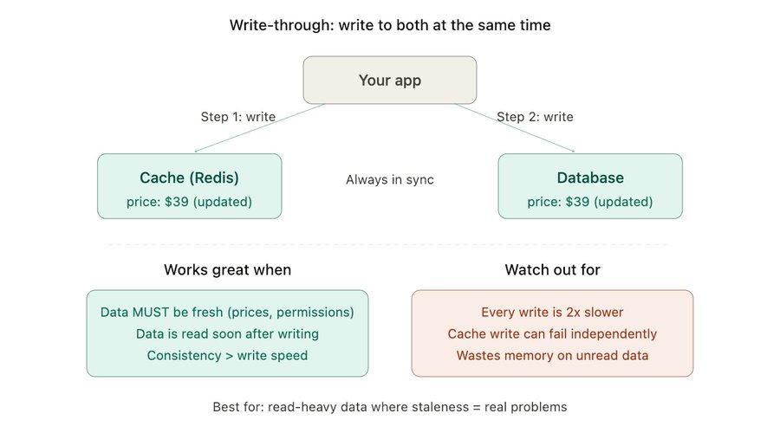

Strategy 2: Write-behind (also called write-back)
This one flips the script. Instead of writing to the database first, you write to the cache first. The database gets updated later, in the background.
How it works:
1. User updates their profile
2. App writes the new data to the cache. Done. Returns immediately.
3. In the background, a separate process flushes that change to the database (maybe every 5 seconds, maybe in batches)

Why it's good:
Writes are insanely fast. The user's request is done the moment the cache is updated. No waiting for the database. Your app feels snappy.
And because you're batching writes to the database, you reduce the total number of DB operations. 100 individual writes become 1 batch insert. Your database is way less stressed.

Why it's scary:
The cache is now the source of truth. Temporarily. And the cache lives in memory.

What happens if Redis crashes before it flushes to the database?
That data is gone. Just gone.

This isn't theoretical. I've seen this happen. A team was using write-behind for analytics events. Redis went down. They lost 45 minutes of data. No recovery possible because it was never written to disk.

When to use it:
- High write throughput where speed matters more than durability (gaming leaderboards, page view counters, real-time analytics)
- Situations where losing a few seconds of data is acceptable
- Reducing database write pressure is a priority

When to absolutely NOT use it:
- Financial transactions. Payments. Anything involving money.
- User data that can't be recreated
- Any system where "we lost your data" is a conversation with legal
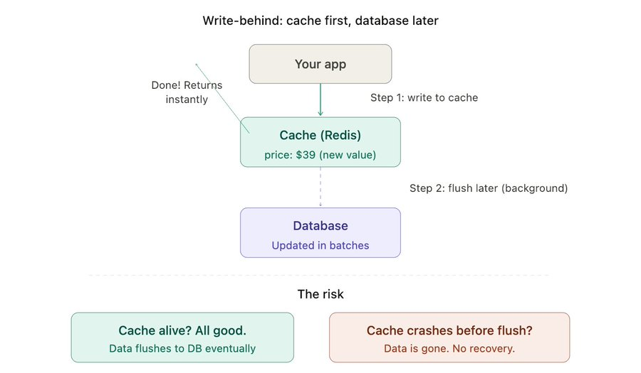
Strategy 3: Write-around (used with cache-aside)
This is the most common pattern in the wild. And honestly, the one I use most often.
How it works:
1. User updates their profile
2. App writes the new data to the database only. Cache is not touched.
3. The old value sits in the cache until it expires (TTL) or gets evicted
4. Next time someone reads that data, cache miss. App fetches from DB, stores fresh value in cache.

That's it. Writes go straight to the database. The cache catches up on the next read.
Why I like it:
- Simple. You don't need to coordinate writes to two places.
- No wasted cache memory. Only data that's actually being read ends up in the cache.
- Your write path is clean. One write. One destination. Done.

The tradeoff:
After every write, the very next read is a cache miss. That one user pays the database latency penalty. Everyone after them gets the cached version.

For most apps, this is totally fine. One slow read out of thousands? Nobody notices.

Where it hurts:
If a piece of data gets written AND read constantly (like a live counter or a frequently edited document), you're constantly busting the cache. Write, miss, fill, write, miss, fill. The cache isn't helping. It's just doing extra work.

For that kind of data, write-through is the better choice.
The cheat code: cache-aside with explicit invalidation
Instead of waiting for TTL to expire, you can delete the cache key on write:

1. Write new data to database
2. Delete the key from cache (not update, delete)
3. Next read triggers a cache fill with fresh data

Why delete instead of update? Because if two writes happen at the same time, updating the cache can cause a race condition where the cache ends up with the older value. Deleting avoids this entirely. The next read always fetches the latest from the database.
This is the pattern I recommend for 80% of use cases. Simple, safe, and the race condition thing alone makes it worth it
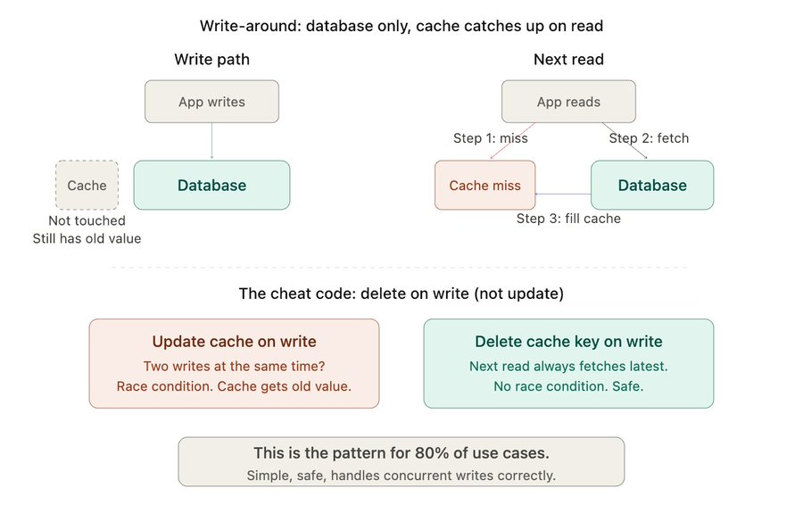
Ok so you've picked a write strategy. Now the other half of the problem.
How do you actually expire stale data?
Two approaches:
1. TTL-based expiry (time-to-live)
Set a timer on every cache entry. When the timer runs out, the data is automatically deleted. Next read triggers a fresh fetch.
Some rules of thumb I use:
- Config data, feature flags → TTL of 5-10 minutes
- Product listings, search results → TTL of 30-60 seconds
- User session data → TTL of 30 minutes
- Versioned static assets → TTL of 1 year (filename changes per version anyway)
Why it works: Dead simple. No extra infrastructure. Set it and forget it.
Where it breaks: You're always accepting some staleness. If the TTL is 60 seconds, a user might see outdated data for up to 60 seconds after a change. For a product listing? Nobody cares. For a bank balance? That's a support ticket.

2. Event-driven invalidation
Instead of waiting for a timer, you actively delete or update the cache the moment the underlying data changes.

How:
- Database writes trigger an event (via CDC, a message queue, or app-level hooks)
- A consumer listens for that event and invalidates the cache immediately

Why it works: Cache is always fresh. No staleness window. Precise.
Where it breaks: You need infrastructure for it. A Kafka consumer or a database change stream (Postgres logical replication, MongoDB change streams, DynamoDB streams). More moving parts. More things to monitor. More things that can fail silently.

Which one should you use?
Honestly? Start with TTL. For most data in most systems, a 30-60 second staleness window is invisible to users.

Add event-driven invalidation only for data where staleness actually costs you something:
- Inventory counts (overselling)
- Pricing (showing wrong price)
- Permissions/auth (security risk)
- Real-time features (chat, live dashboards)

Everything else? TTL. Don't over-engineer it.

Quick decision cheat sheet:

Format: What you're caching → Strategy → Invalidation

1) Product listings → Write-around → TTL (30-60s)
2) User sessions → Write-through → TTL (30 min)
3) Analytics counters → Write-behind → TTL (short)
4) Inventory / pricing → Write-through → Event-driven
5) Feature flags → Write-around → TTL (5 min)
6) User permissions → Write-through → Event-driven
